**Entertainment Website**

**[www.pickcross.com]**

A REPORT

submitted by

**Kunwarjeet Singh (12MSE1086)**

*in partial fulfilment for the award*

of

**M. Tech. Software Engineering**

**(5 year Integrated Programme)**

**School of Computing Science and Engineering**



**September 2015**



**School of Computing Science and Engineering**

**DECLARATION**

I hereby declare that the project entitled **Entertainment Website** submitted by me to the School of Computing Science and Engineering, VIT University, Chennai Campus, Chennai 600127 in partial fulfilment of the requirements for the award of the degree of **Master of Technology -Software Engineering (5 year Integrated Programme)** is a record of bonafide work carried out by me**.** I further declare that the work reported in this report has not been submitted and will not be submitted, either in part or in full, for the award of any other degree or diploma of this institute or of any other institute or university.

Signature

**Kunwarjeet Singh (12MSE1086)**



**School of Computing Science and Engineering**

**CERTIFICATE**

The project report entitled **Entertainment Website** is prepared and submitted by **Kunwarjeet Singh (Register No: 12MSE1086).** Ithas been found satisfactory in terms of scope, quality and presentation as partial fulfilment of the requirements for the award of the degree of **Master of Technology – Software Engineering (5 year Integrated Programme)** in VIT University, Chennai Campus, Chennai, India.

**Examined by**:

**Prof. Kanchanadevi V. Prof. Harini S.**

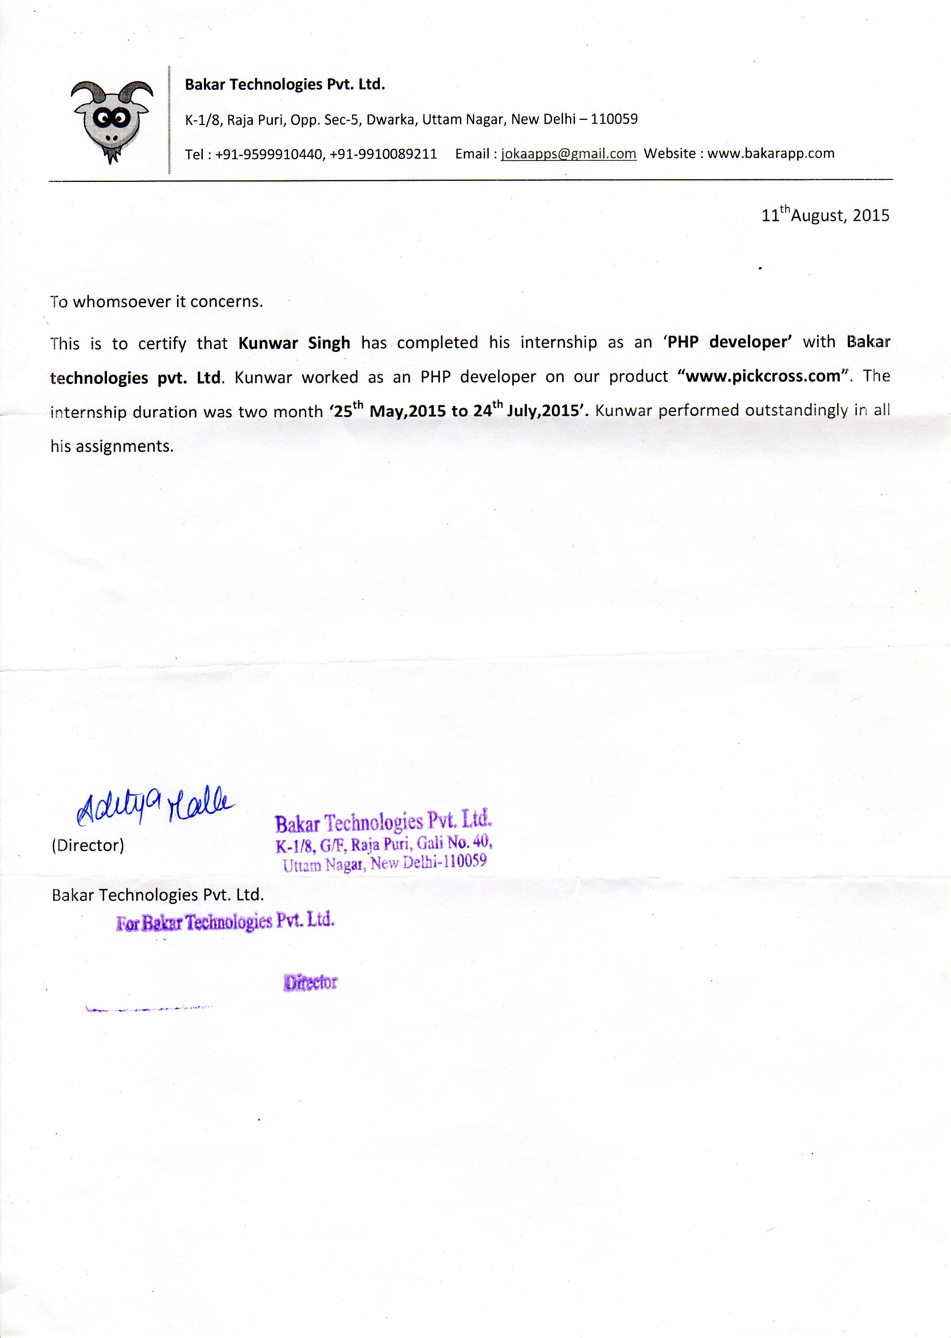 **ACKNOWLEDGEMENT**

I would like to take this opportunity to acknowledge the whole hearted support extended by **Blessit George (My Guide)** for guiding me throughout the internship. I express my deep sense of gratitude towards **Aditya Malla (CEO Bakar Technologies)** for giving me the chance to work with his company and providing me a cutting edge technology experience. I would also like to express my sincere sense of gratitude towards my **Program Manager Prof. Maheswari N.** and our **Dean Jagannathan L**. for giving me a chance to persue **Industrial Internship**. I am also grateful to all the faculties of SCSE department of **VIT University – Chennai Campus**. Finally I would like thank my **parents** who supported me over these years and allowed me to realize my own potential.

**CONTENTS**

|  |  |  |
| --- | --- | --- |
| **Chapter** | **Title** | **Page** |
|  |  |  |
|  | Title Page | i |
|  | Declaration | ii |
|  | Certificate | iii |
|  | Industry certificate | iv |
|  | Acknowledgement | v |
|  | Table of contents | vi |
|  | List of Figures | viii |
|  | List of Abbreviation | ix |
|  | Abstract | x |
|  |  |  |
| 1 | Introduction | 1 |
| 2 | Methodology | 2 |
| 2.1 | Understanding the Requirements | 2 |
| 2.2 | Elicitation and Testing of Requirements | 2 |
| 2.3 | Software Design and Architecture | 2 |
| 2.4 | Implementation | 2 |
| 2.5 | Testing | 2 |
| 2.6 | Beta Version | 2 |
| 2.7 | Live Version | 2 |
| 2.8 | Front End Technologies | 3 |
| 2.9 | Backend Technologies | 3 |
| 2.10 | Database & Hosting | 3 |
| 2.11 | Software Tools | 3 |
| 3 | Observation and Discussion | 4 |
| 4 | Work Done | 5 |
| 4.1 | Responsive Design | 5 |
| 4.2 | Dynamic Search | 6 |
| 4.3 | Meme Generator Tool | 6 |
| 4.4 | Social Login | 7 |
| 4.5 | SEO- URL | 7 |
| 4.6 | User Actions | 7 |
| 4.7 | User Profile | 8 |
| 4.8 | Notification System | 8 |
| 4.9 | Content Sharing | 8 |
| 4.10 | Iconography | 8 |
| 4.11 | Reward System | 8 |
| **Chapter** | **Title** | **Page** |
|  |  |  |
|  |  |  |
| 4.12 | Pagination | 9 |
| 4.13 | Admin Panel | 9 |
| 5 | Conclusion and Outlook | 10 |
| 6 | References | 11 |
| 7 | Appendix – I (Sample source code, screenshots, etc.) | 12 |

|  |  |  |
| --- | --- | --- |
|  | **LIST OF FIGURES** |  |
|  | **Title** | **Page** |
| Fig 2.1 | Agile Development Model | 2 |
| Fig 2.2 | Technologies Used | 3 |
| Fig 4.1 | Home Page 1366x768 view | 5 |
| Fig 4.2 | Home Page Mobile View | 5 |
| Fig 4.3 | Mobile Menu Dropdown | 5 |
| Fig 4.4 | Meme Generator | 6 |
| Fig 4.5 | Social Login | 7 |
| Fig 4.6 | SEO – URL | 7 |
| Fig 4.7 | User Actions – Like, Comments, Share, Report | 7 |
| Fig 4.8 | User Profile | 8 |
| Fig 4.9 | Admin Panel – User Maintenance | 9 |
| Fig 4.10 | Admin Panel - Tags Maintenance | 9 |

**LIST OF ABBREVIATIONS**

|  |  |
| --- | --- |
| **Abbreviation** | **Expansion** |
| WWW | World Wide Web |
| PHP | Pre-Hypertext Processor |
| Maint | Maintenance |
| CMS | Content Managemant System |
| LAMP | Linux Apache MySQL PHP |
| ORM | Object Relational Mapping |
| UI | User Interface |
| URL | Uniform Resource Locator |

**ABSTRACT**

My project was to develop a Social Media Entertainment Website where users can upload and share content either user-generated or found on other social media websites. 9gag is the current competitor which is widely used for content sharing. Currently in India we don’t have any strong competitor. Online meme creator is not that flexible, so still some users have to create using offline tool. Our Meme Generator tool is very flexible for creation of memes and we also allow user signature. Our main aim is to capture Indian market and allow advanced creation of memes by users.

1. **INTRODUCTION**

Social Media is defined as a group of internet based applications that allow people to create, share, exchange information, ideas and pictures/videos in virtual communities. Social media technologies take on many different forms including blogs, business networks, enterprise

Social networks, forums, microblogs, photo sharing, products/services review,

Social bookmarking, social gaming, social networks, video sharing and virtual worlds.

Our project Social Media Entertainment website focuses on content creation and sharing by users. Users can share their own content or content found on other Social Media websites.

They can also share content of this website to other social media networks like Facebook, Twitter, Google+. We have a proper content management system which keeps track of all useractions such as likes, comments, share, view etc. A proper reward system is there for users. Users get rewards for their actions which keeps them participating actively. We have an Online Meme Generator tool where users can create advanced content and can share them here or to other social media websites. It’s a responsive website suitable for PC, alongwith mobiles as well as tablets.

Following Sections depict my work done throughout my 2 Months in Industrial Internship.

1. 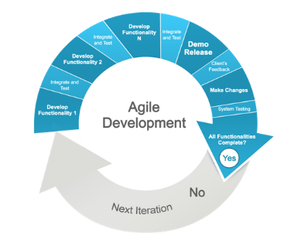**METHODOLOGY**

The whole website was made from stack. Agile Software Model was used in developing whole application. Following were carried to achieve goal. Module by moule project was implemented.

* 1. **UNDERSTANDING THE REQUIREMENTS**

Whole idea of the website was presented the first day. Requirements work was

already done by their staff, I was hired as a PHP developer.

* 1. **ELICITATION AND TESTING OF REQUIREMENTS**

Requirements elicitation was done along with testing, and some final set of

requirements were finalized. Agile Model was selected.

* 1. **SOFTWARE DESIGN AND ARCHITECTURE**

Firstly the Database ER Diagram and class diagram was designed and worked on.

Then wireframes were worked and architecture of the website was planned and

decided.

* 1. **IMPLEMENTATION**

Front-End and Backend were designed simultaneously according to Module. Unit

Testing and Adhoc testing was being done as code was made. A stable version

was made and uploaded to Cloud. After 3 stable versions, minor implementation

was done directly on the cloud.

* 1. **TESTING**

5-6 days were given for testing after a stable version was made. Test Data was

taken from 9gag, personal experience and some was created by me. System

Testing was done and bugs found were fixed.

* 1. **BETA VERSION**

Beta version [www.pickcrossbeta.co.in](http://www.pickcrossbeta.co.in) was made live users were told to play with

it. Bugs found during beta version were fixed.

* 1. **LIVE VERSION**

Finally, the website [www.pickcross.com](http://www.pickcross.com) was live in last days of my internship

and was at maintenance stage.

* 1. **FRONT – END TECHNOLOGIES**

HTML5, CSS3, JavaScript, JQuery, AJAX, JSON, Bootstrap Framework

* 1. **BACK – END TECHNOLOGIES**

PHP5, Laravel Framework, Eloquent ORM

* 1. **DATABASE & HOSTING**

MySQL, LAMP, Google Cloud, GoDaddy Domain

* 1. **SOFTWARE TOOLS**

NetBeans, Notepad, Firefox, Chrome



Fig 2.2 Technologies used

1. **OBSERVATION AND DISCUSSION**

Duringmy 2 months industrial internship, I have observed some day to day operations and some big ongoing projects. My first impression was company resembling a small but presented well maintained and cool working environment. Every employee know exactly what they are supposed to do without constant supervision.

Sometimes the employees often call it a day during last hour and enjoy the talk with others. I would have guessed that it might affect work progress but tasks were always finished in a timely manner and people were very cooperating on one of the highest levels.

All my interactions with the staff at the company were extremely friendly. The employees were welcoming and accommodating, knowledgeable and helpful to the highest degree, as the work environment was professional and cordial.

1. **WORK DONE**
   1. **RESPONSIVE DESIGN**

Task was to create a fully responsive UI, responsive to all screen sizes. Bootstrap Framework was used to fulfil this requirement. Functionality differs as screen size vary.

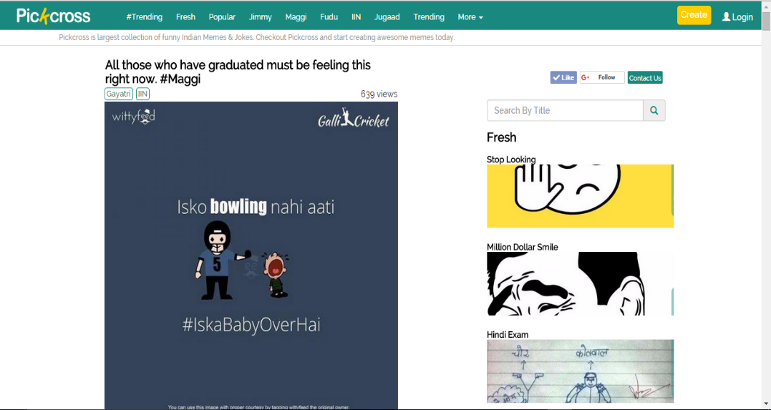

Fig 4.1 Home Page 1366x768 view

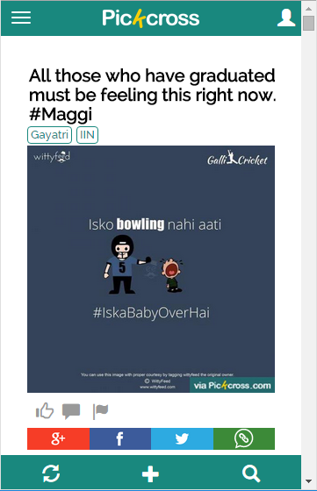 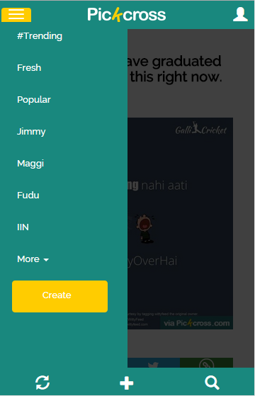

Fig 4.2 Home Mobile View Fig 4.3 Mobile Menu Dropdown

* 1. **DYNAMIC SEARCH**

AJAX was used for providing dynamic search. Views inside a search were created again using Bootstrap so Responsive + Dynamic according to screen size. Search view in mobiles differs to that in PC.

* 1. **MEME GENERATOR TOOL**

Meme generator is our content-creator tool made using full JavaScript and JQuery for faster work as content has to be displayed dynamically as values changes.

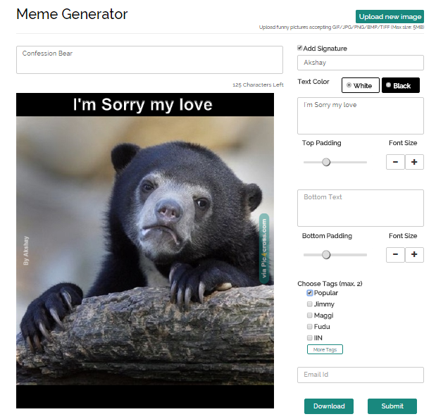

Fig 4.4 Meme Generator

* 1. 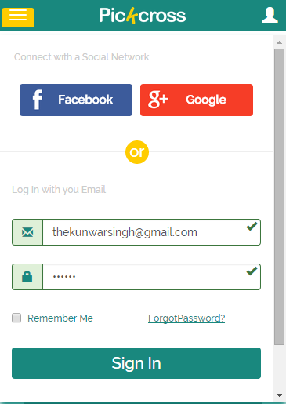**SOCIAL LOGIN**

This was one of the trickiest as to provide secure login functionality using Social accounts such as Facebook and Twitter.

* 1. **SEO - URL**

The URL’s were to be made Search Engine Optimized. Care was taken as some sets of characters are not allowed in url.

Fig 4.5 Social Login Mobile

C:\Users\Kunwar\Desktop\Review Intern\5b.PNG

Fig 4.6 SEO - URL

* 1. **USER ACTIONS**

Proper CMS was made to keep track of each user action.

User Actions such as Like, Comment, View, Report.

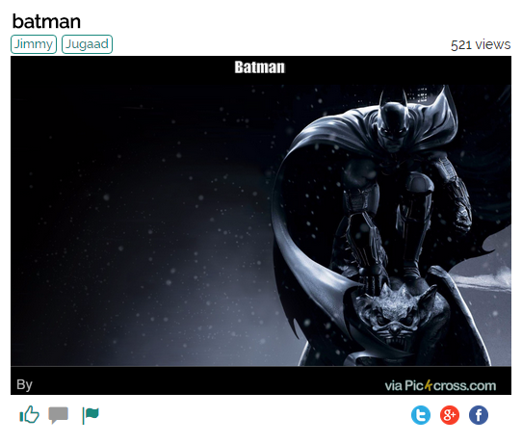

Fig 4.7 User Like, Comment View

* 1. **USER PROFILE**

User Profile module was made where users can see their activities like – their Favourites, Commented, Viewed. Users can update their avatar and other basic info.

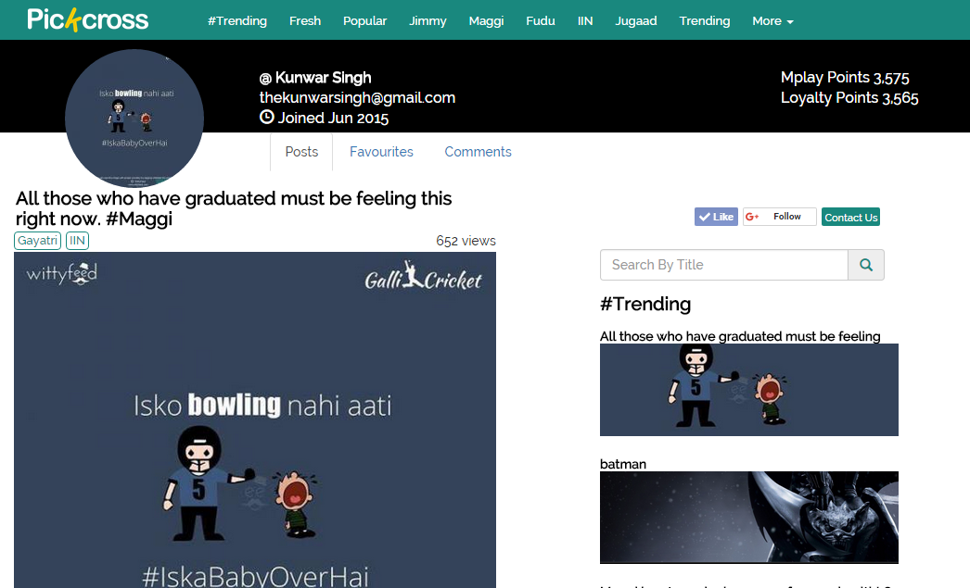

Fig 4.8 User Profile View

* 1. **NOTIFICATION SYSTEM**

Notification system is very important in every social website. Notification Panel containing recent notifications for a user was properly made.

* 1. **CONTENT SHARING**

A proper sharing mechanism was made using developer tools for a particular social media website. Memes can be shared to other Social Websites like Facebook, Twitter, Google+.

* 1. **ICONOGRAPHY**

Proper icons and color schemes along with font style was selected to give a unique look to website.

* 1. **REWARD SYSTEM**

Users were given points on each task performed. A proper reward system was there.

* 1. **PAGINATION**

Ajax was used to take care of pagination, to load content dynamically on scroll down.

* 1. **ADMIN PANEL**

Admin panel was created to manage users, content, tags and UI. Dynamic tag maintenance was one of the trickiest part.

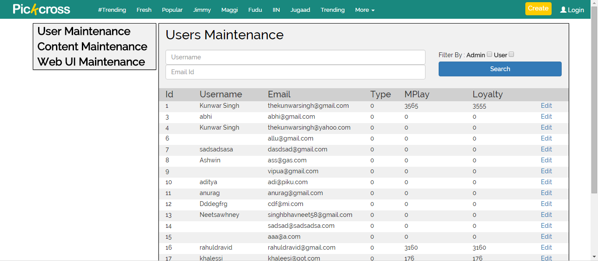

Fig 4.9 Admin Panel – User Maintenance

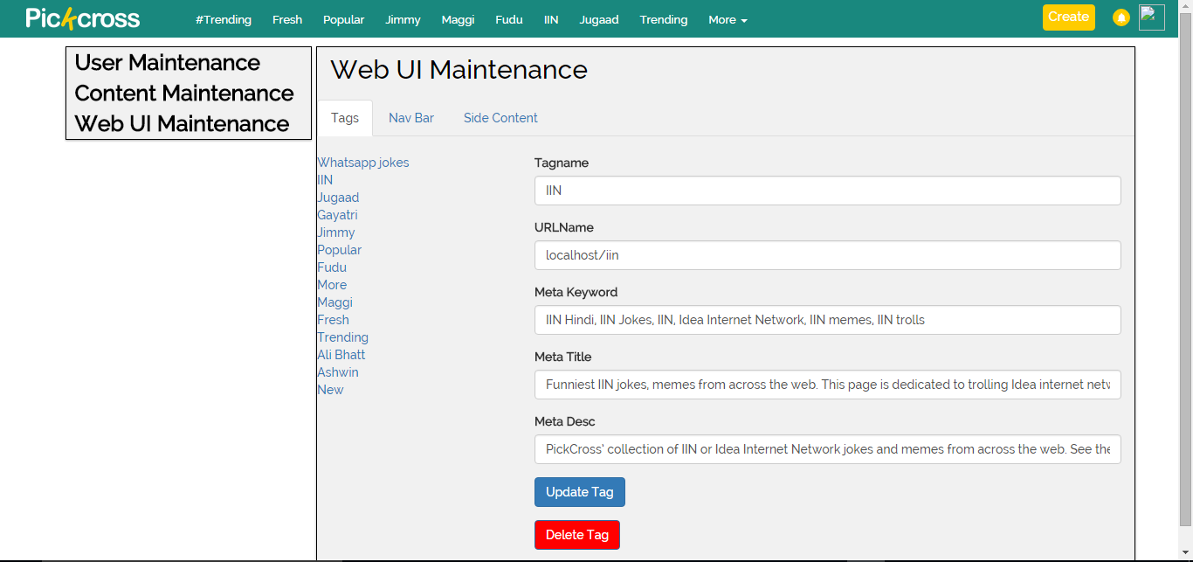

Fig 4.10 Admin Panel – Tags Maintenance

1. **CONCLUSION AND OUTLOOK**

The 2 months Summer Internship that I had undertaken at Bakar Technologies, New Delhi provided me an experience of working in start-up company, working on latest technology and bringing the best out of me. During this, I had a chance to work with highly experienced and knowledgeable employees. The internship helped me to work on a website from stack, real world problem solving and learning new technologies. The industrial internship will go a long way in helping me throughout my studies as well as in my Software Engineering career.

1. **REFERENCES**
   * BLESSIT GEORGE

SENIOR WEB DEVELOPER

BAKAR TECHNOLOGIES, NEW DELHI

+919599644438, [blessit.george@gmail.com](mailto:blessit.george@gmail.com)

* ADITYA MALLA

CHIEF EXECUTING OFFICER

BAKAR TECHNOLOGIES, NEW DELHI

+919910089211, [adityamalla@gmail.com](mailto:adityamalla@gmail.com)

* + ANURAG BALIHARA

CHIEF MARKETING OFFICER

BAKAR TECHNOLOGIES, NEW DELHI

+919599910440, anurag.balihara@gmail.com

* [www.pickcross.com](http://www.pickcross.com)

[www.facebook.com/pickcross](http://www.facebook.com/pickcross)

www.twitter.com/pickcrossdotcom

1. **APPENDIX – I**

**SAMPLE CODE & SCREENSHOTS**

**Meme Generator on image load function**

loadImg = function (img) {

console.log(e.ifile.files[0]);

if (e.ifile.files[0].size>5242880)

{ alert("Kindly select image with size less than 5MB"); return; }

if (!(/\.(gif|jpg|jpeg|tiff|png|bmp)$/i).test(e.ifile.value))

{ alert("Kindly select image of type gif,jpg,jpeg,tiff,png,bmp"); return; }

e.box2.style.display = "block";

reader.readAsDataURL(e.ifile.files[0]);

reader.onload = function () {

image.src = reader.result;

image.onload = function () {

if(orientation==="vertical"){validateVertical();}

if(orientation==="horizontal"){validateHorizontal();}

ctxt.textAlign = "center";

ctxt.fillStyle = textColor;

ctxt.strokeStyle = textStrokeColor;

ctxt.lineWidth = 2;

renderMeme();

e.library.style.display = "none";

makeOrientationBlock();

}; };};

**Meme Generator Img Validator**

validateHorizontal = function() {

var max_width=1650;

var max_height=550;

if(image.height>550){

var scale_width = max_width / image.width;

var scale_height = max_height / image.height;

var scale = Math.min(scale_width, scale_height);

console.log("scale_width="+scale_width);

console.log("scale_height="+scale_height);

image.width = image.width * scale; // 608

image.height = image.height * scale;

console.log("width="+image.width);

console.log("height="+image.height);

} e.c.width=550;

if(image.width<250)

{ alert("Kindly select image with a min width of 250px for better view"); return; }

if(image.width>1650)

{ alert("Kindly select image with a max width of 1650px for better view"); return; }

e.c.height=image.width;

imgHeight = image.width;

canvasHeight=image.width;

if(image.height>550){

xImg=e.c.width;

}else{

xImg= (550-image.height)/2;

console.log("x="+xImg);

}

};

**Meme Generator Meme Render – executes on each input change**

renderMeme = function () {

renderColor();

ctxt.drawImage(image, xImg, e.topPadding.value, image.width, imgHeight);

if(imgHeight<550 && imgHeight>=250){ e.watermark = get("watermark2");

ctxt.drawImage(e.watermark, e.c.width-220, e.c.height - 10 -lineHeightBottom ,130,20 );

signatureFontSize="12px";} //important

if(imgHeight<950 && imgHeight>=550){ e.watermark = get("watermark2");

ctxt.drawImage(e.watermark, e.c.width-220, e.c.height - 10 -lineHeightBottom ,89,10 );

signatureFontSize="12px";}

if(imgHeight<1650 && imgHeight>=950){ e.watermark = get("watermark2");

ctxt.drawImage(e.watermark, e.c.width-220, e.c.height - 10 -lineHeightBottom ,304,34 );

signatureFontSize="12px";}

//drawRotatedImage(e.watermark, e.c.width-40, e.c.height -(e.c.height/2), 270);

e.c.height=canvasHeight+e.topPadding.value*1+e.bottomPadding.value*1;

ctxt.fillStyle = "#000000";

ctxt.fillRect(0,0,e.c.width,e.topPadding.value); //Top

ctxt.fillRect(0,canvasHeight+e.topPadding.value*1,e.c.width,e.bottomPadding.value); //Bottom

if(orientation==="vertical"){

ctxt.fillRect(0,e.topPadding.value,xImg,imgHeight); //Left

ctxt.fillRect(image.width + xImg,e.topPadding.value,xImg,imgHeight); //Right

}

if(orientation==="horizontal"){

ctxt.save();

ctxt.translate(ctxt.width/2,ctxt.height/2);

ctxt.rotate(90 * TO_RADIANS);

ctxt.fillRect(e.topPadding.value,-xImg,imgHeight,xImg); //Left

ctxt.fillRect(e.topPadding.value,-e.c.width,imgHeight,xImg); //Right

ctxt.restore();

}

// ctxt.drawImage(image, e.topPadding.value, -e.c.width+xImg, imgHeight, image.height);

ctxt.fillStyle = textColor;

ctxt.textAlign = "center";

writeBottomMeme(e.bottomline.value, e.c.width / 2, e.c.height - 10);

writeTopMeme(e.topline.value, e.c.width / 2, toptextPad);

renderSignature();

console.log("hello");

e.file.value = e.c.toDataURL("image/png");

console.log( "this="+e.file.value);

};

**AJAX call on search for mobile view**

function mSearch(searchBar,type){

console.log("type="+type);

var id =searchBar.id;

console.log("id="+id);

var value=document.getElementById(id).value;

console.log("value="+document.getElementById(id).value); // Value unable to fetch

$.ajax({

type: "POST",

url: "/liveSearch",

headers: { 'X-CSRF-Token' : $('meta[name=_token]').attr('content') },

data: "search="+value+"&type="+type,

cache: false,

success: function(data)

{ $("#mSearchResult").html(data); } });}

**Mobile User Profile View Mobile Account Login Mobile New Registration**

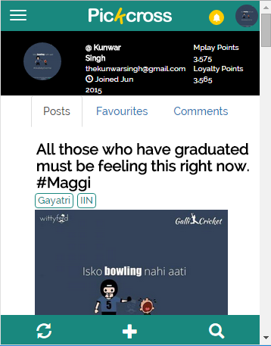 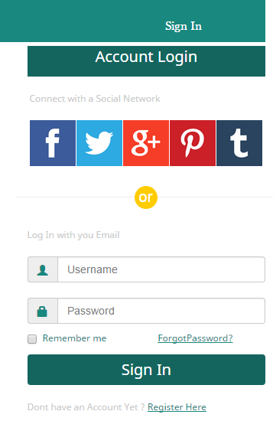 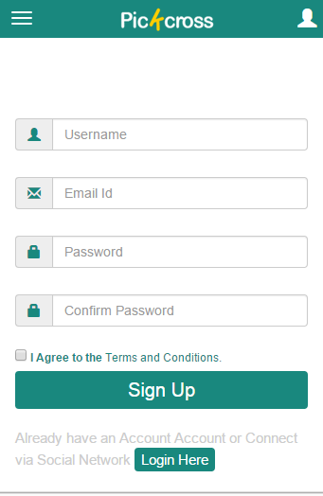



C:\Users\Kunwar\Desktop\Review Intern\title.png